Outreach Nutrition Topics & Materials

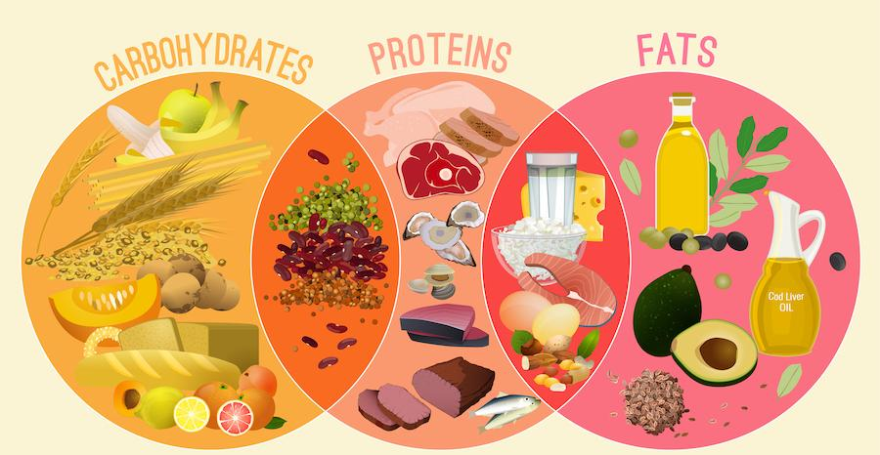
MACRO BREAKDOWN
TOPIC: Fueling your body, whether for daily or fitness needs, is crucial for optimal productivity!
Video: Eating For Energy
Handout: Sustainable Energy

TOPIC: Explore a variety of protein sources and reap their benefits to support your body.
Video: Power of Protein
Handout: Protein Next Level

TOPIC: Carbohydrates are essential for energy and health, get the facts to make quality choices.
Video: Low-Carb Diet Lowdown
Handout: Keto Diet Review

MEAL PLANNING
TOPIC: Improve your every day with quick and simple life tips.
Video: 9 Well-Being Life Hacks
Handout: More Food Less Work

TOPIC: Make mealtime easy with a pantry stocked with the basics.
Video: Healthy Pantry Basics
Handout: Do More with Pantry Basics

TOPIC: Use frozen vegetables to provide nutrition dishes in any season.
Video: Making Frozen Foods Fresh
Handout: Healthy Frozen Foods

TOPIC: Tired of the same ‘go-to’ meals? Get healthy, simple ideas to inspire your meal planning.
Video: Inspiration in the Kitchen
Handout: Finding a Kitchen Plan to Work for You

TOPIC: Learn to use the Nutrition Facts Label to guide your choices.
Video: Understanding Food Labels
Handout: Making More with Less

DISEASE PREVENTION & MANAGEMENT
TOPIC Improve your outlook by learning which foods can affect mood.
Video: Good Mood Foods
Handout: Mediterranean For Mood

TOPIC: Make healthy choices to decrease your risk of disease.
Video: Boost Immunity with Food
Handout: Cooking For Gut Health

